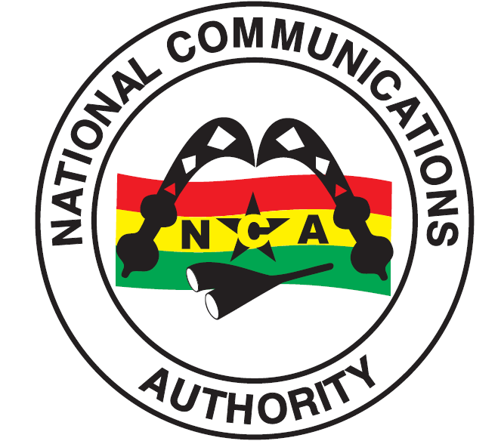
INDUSTRY INFORMATION - TELECOM SUBSCRIPTIONS FOR jULY 2016
National Communications Authority
October 10, 2016

Contents
1. Introduction 4
2. Mobile Voice Subscription for July 2016. 4
3. Fixed Telephony 5
4 Mobile Data Figures for July 2016 6
4.3 Broadband Wireless Access (BWA) Operators 7

Abbreviations
NCA National Communications Authority
BWA Broadband Wireless Access

TELECOM SUBSCRIPTIONS FOR JULY 2016

Introduction
This report highlights trends in the telecommunication industry for July 2016. The report documents trends that have occurred in the country’s mobile voice, fixed telephony, mobile data and Broadband Wireless Access (BWA) for the month under review.

Mobile Voice Subscription for July 2016.
At the end of July 2016, the total number of mobile voice subscribers had increased from 36,613,987 as at the end of June 2016 to 36,739,810 as at the end of July 2016. This represents a percentage increase of 0.34%. The total penetration rate for the month under review was 132.08%.
MTN’s voice subscriber figures for the period was 17,774,481, representing a percentage increase of 1.11% from June 2016’s figure of 17,579,045. MTN’s market share for the month under review was 48.38%.
Vodafone’s mobile voice subscribers increased from 8,093,710 as at the end of June 2016 to 8,160,351 as at the end of July 2016. This represents a percentage increase of 0.82%. Vodafone’s market share for July 2016 was 22.21%.
Tigo’s voice subscribers decreased from 5,261,454 as at the end of June 2016 to 5,211,811 as at the end of July 2016. This indicates a percentage decrease of 0.94%. Their market share for the month under review was 14.19%.
Airtel’s voice subscribers decreased from 4,678,736 as at the end of June 2016 to 4,636,374 as at the end of July 2016. This represents a percentage decrease of 0.91%. Their total market share for the month under review was 12.62%.
Glo’s voice subscribers decreased from 897,082 as at the end of June 2016 to 854,912 at the end of July 2016. This reflects a percentage decrease of 4.70% for the month. Their total market share for the month under review was 2.33%.
Expresso’s voice subscriber figures decreased from 103,960 as at the end of June 2016 to 101,881 as at the end of July 2016. This represents a percentage decrease of 2%. Their total market share for the month under review was 0.28%.

  - Chart 1 – Mobile Voice Market Share for July 2016

  - Chart 2 – Mobile Voice Subscription Trends from January to July 2016

Fixed Telephony
There are two (2) operators providing fixed line services to the public in Ghana. These operators are Vodafone and Airtel. As at July 2016, the total subscriptions for the fixed operators were 256,340 representing a percentage decrease of 0.12% from the previous month. Vodafone recorded a total subscriber base of 248,463 whiles Airtel ended the month with 7,877 subscribers.

3.1 Chart 3 – Fixed Voice Telephony for July 2016

FIXED TELEPHONY OPERATORS

Mobile Data Figures for July 2016
At the end of August 2016, the total subscribers of mobile data subscribers in the country were 18,825,916 with a total penetration of 67.68%.

4.1 Cellular Mobile Data Operators
MTN’s mobile data subscribers for July 2016 were 9,429,065. Their market share for the month under review was 50.09%.
The total number of subscribers for Vodafone’s mobile data in July 2016 was 3,278,834. This is reflected in their market share of 17.42%
Airtel’s mobile data subscribers for July 2016 were 3,052,219. Their market share for the month was 16.21%.
Tigo’s data subscribers for July 2016 were 2,743,364. Tigo’s market share for the month under review was 14.57%.
Glo recorded data subscriber figure of 281,724 at the end of July 2016. This reflects a market share of 1.50%.
Expresso’s mobile data subscriber figures as at the end of July 2016 were 40,710. This represents a market share of 0.22% for the month under review.

4.2 Chart 4 –Mobile Data market Share for July 2016

4.3 Broadband Wireless Access (BWA) Operators
As at the end of July 2016, the total number of subscribers for Broadband Wireless Access data was 94,706. Surfline’s subscriber base was 66,935. Blu Ghana recorded a total subscriber figure of 1,235 and Broadband Home recorded a total of 26,536 subscribers.

  - Chart 5 – Broadband Wireless Access (BWA) Market Share for July 2016

4.5 Chart 6 – Total Mobile Data Subscriptions Trends from January to July 2016

4.6 Chart 7 – Total Mobile Data Market Share for July 2016

TOTAL MARKET SHARE PER DATA OPERATOR

Issued by the National Communications Authority,
No. 6 Airport City, Accra.
Tel: (0)30 – 2776621/2771701 or 050-145-1522/3.
E-mail: info@nca.org.gh
Date – Monday, 10th October, 2016

