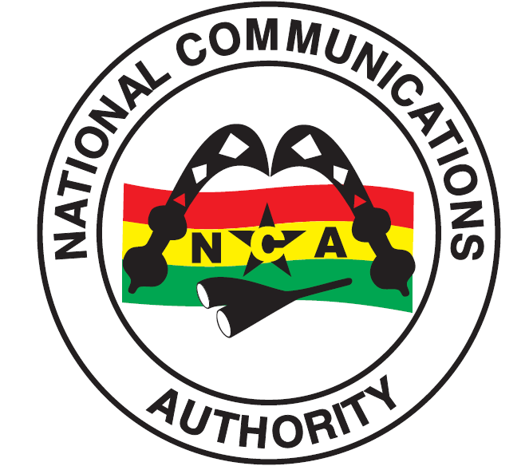
INDUSTRY INFORMATION - TELECOM SUBSCRIPTIONS FOR AUGUST 2016
National Communications Authority
October 10, 2016

Table of Contents
Introduction 4
Mobile Voice Subscriptions for August 2016. 4
Fixed Telephony 6
Mobile Data Figures for August 2016 6
Broadband Wireless Access (BWA) Operators 7

Abbreviations
NCA National Communications Authority
BWA Broadband Wireless Access

TELECOM SUBSCRIPTIONS FOR AUGUST 2016

Introduction
This report highlights subscriptions within the telecommunication industry for August 2016. The report also presents trends that have occurred in the country’s mobile voice subscriptions, fixed telephony trends, mobile data and Broadband Wireless Access (BWA) from January to August, 2016.

Mobile Voice Subscription for August 2016.
At the end of August 2016, the total number of mobile voice subscribers had increased from 36,739,810 as at the end of July 2016 to 36,912,019 as at the end of August 2016. This represents a percentage increase of 0.47%. The total penetration rate for the month under review was 132.44%.
MTN’s voice subscriber figures for the period was 17,890,958, representing a percentage increase of 0.66% from July’s 2016’s figure of 17,774,481. MTN’s market share for the month under review was 48.47%.
Vodafone’s mobile voice subscribers increased from 8,160,351 at the end of July 2016 to 8,223,957 as at the end of August 2016. This represents a percentage increase of 0.78%. Vodafone’s market share for August 2016 was 22.28%.
Tigo’s voice subscribers increased from 5,211,811 as at the end of July 2016 to 5,225,021 as at the end of August 2016. This indicates a percentage increase of 0.25%. Their market share for the month under review was 14.16%.
Airtel’s voice subscribers increased from 4,636,374 as at the end of June 2016 to 4,642,569 as at the end of August 2016. This represents a percentage increase of 0.13%. Their total market share for the month under review was 12.58%.
Glo’s voice subscribers decreased from 854,912 as at the end of July 2016 to 822,539 at the end of August 2016. This reflects a percentage decrease 3.79% for the month. Their total market share for the month under review was 2.23%.
Expresso’s voice subscriber figures increased from 101,881 as at the end of July 2016 to 106,975 as at the end of August 2016. This represents a percentage increase of 5%. Their total market share for the month under review was 0.29%.

  - Chart 1 – Mobile Voice Market Share for August 2016

2.2 Chart 2 – Mobile Voice Subscriptions Trends from January to August 2016

Fixed Telephony
There are two (2) operators providing fixed line services to the public in Ghana. These operators are Vodafone and Airtel. As at August 2016, the total subscriptions for the fixed operators were 256,751 representing a percentage increase of 0.16% from the previous month. Vodafone recorded a total subscriber base of 249,043 whiles Airtel ended the month with 7,708 subscribers.
3.1 Chart 3 – Fixed Telephony Subscriptions for August 2016

FIXED TELEPHONY OPERATORS

Mobile Data Figures for August 2016
At the end of August 2016, the total subscribers of mobile data subscribers in the country were 19,125,469 with a penetration rate of 68.62%.

4.1 Cellular Mobile Data Operators
MTN’s mobile data subscribers for August 2016 were 9,608,952. Their market share for the month under review was 50.24%.
The total number of subscribers for Vodafone’s mobile data in August 2016 was 3,301,319. This is reflected in their market share of 17.26%
Airtel’s mobile data subscribers for August 2016 were 3,082,800. Their market share for the month was 16.12%.
Tigo’s data subscribers for August 2016 were 2,817,896. Tigo’s market share for the month under review was 14.73%.
Glo recorded data subscriber figures of 271,756 at the end of August 2016. This reflects a market share of 1.42%.
Expresso’s mobile data subscriber figures as at the end of August 2016 were 42,746. This represents a market share of 0.22% for the month under review.

  - Chart 4 – Mobile Data Market Share for August 2016

4.3 Broadband Wireless Access (BWA) Operators
As at the end of August 2016, the total number of subscribers for Broadband Wireless Access data was 100,907. Surfline’s subscriber base was 73,244. Blu Ghana recorded a total subscriber figure of 1,184 and Broadband Home recorded a total of 26,479 subscribers.

  - Chart 5 – Broadband Wireless Access (BWA) Market Share for August 2016

4.5 Chart 6 – Total Mobile Data Subscriptions Trends from January to August 2016

4.6 Chart 7 – Total Mobile Data Market Share for August 2016

TOTAL MARKET SHARE PER DATA OPERATOR

Issued by the National Communications Authority,
No. 6 Airport City, Accra.
Tel: (0)30 – 2776621/2771701 or 050-145-1522/3.
E-mail: info@nca.org.gh
Date – Monday, 10th October, 2016

